**DC Installation:**

* **Step 1:** Unzip **DeploymentCenter_14.3.zip** and go to **<unzip_location>\DeploymentCenter_14.3\deployment_center.**
* **Step 2:** Open **install_config.properties** in notepad++.  
  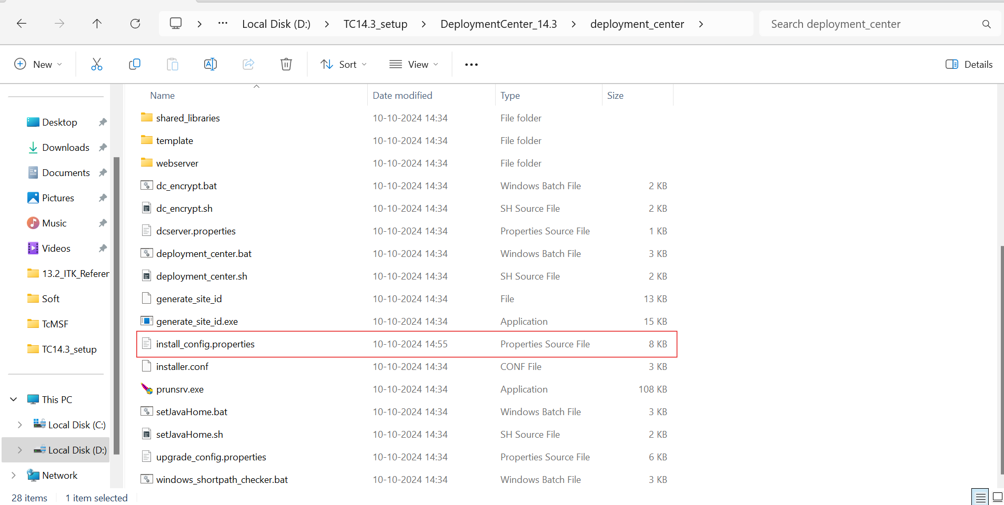
* **Step 3:** In ‘serverDir’ & ‘repoDir’ give the path where you have to install the DC.  
  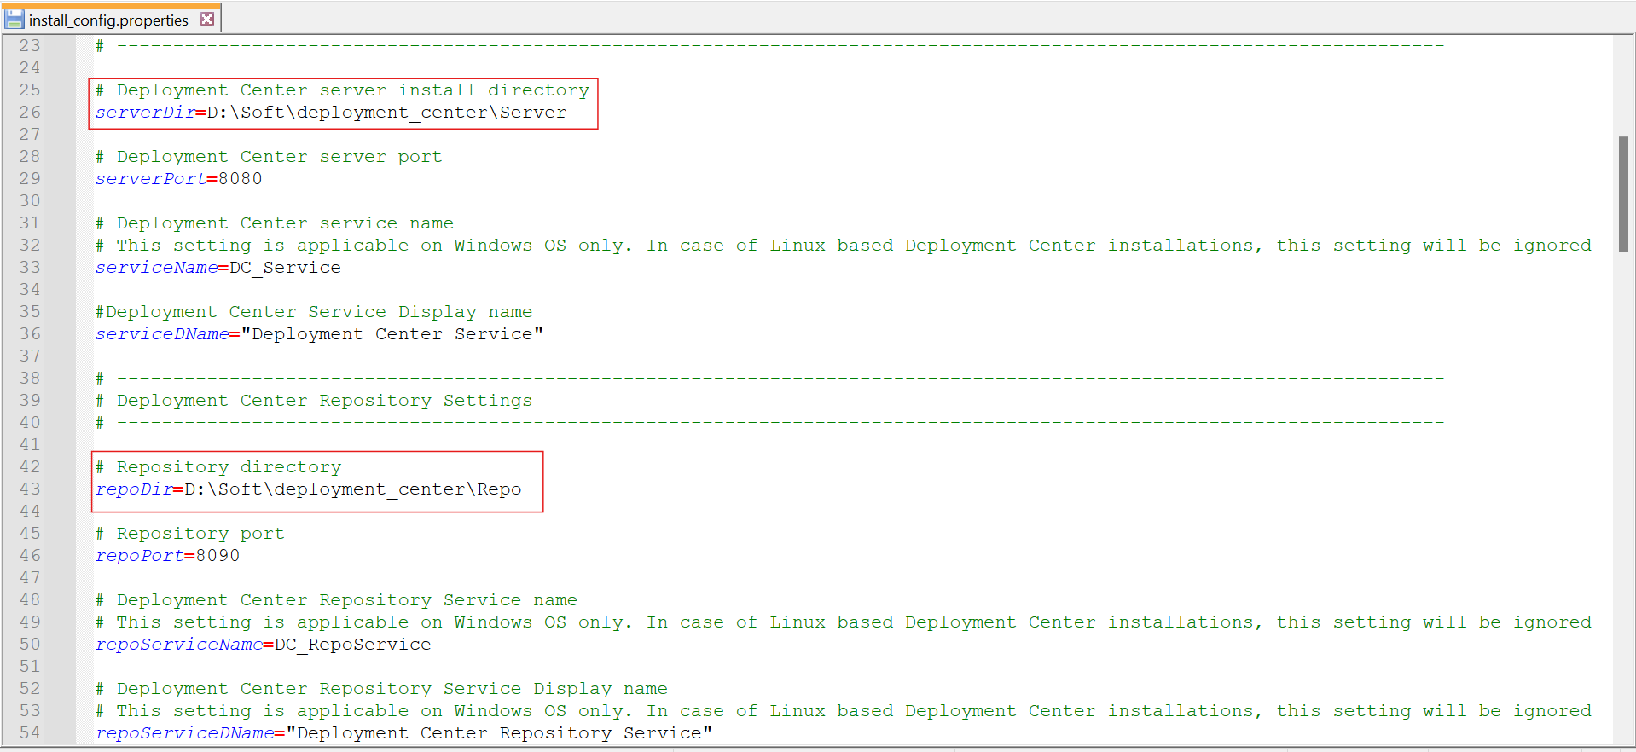
* **Step 4:** Give username & password as “infodba” and save the file.  
  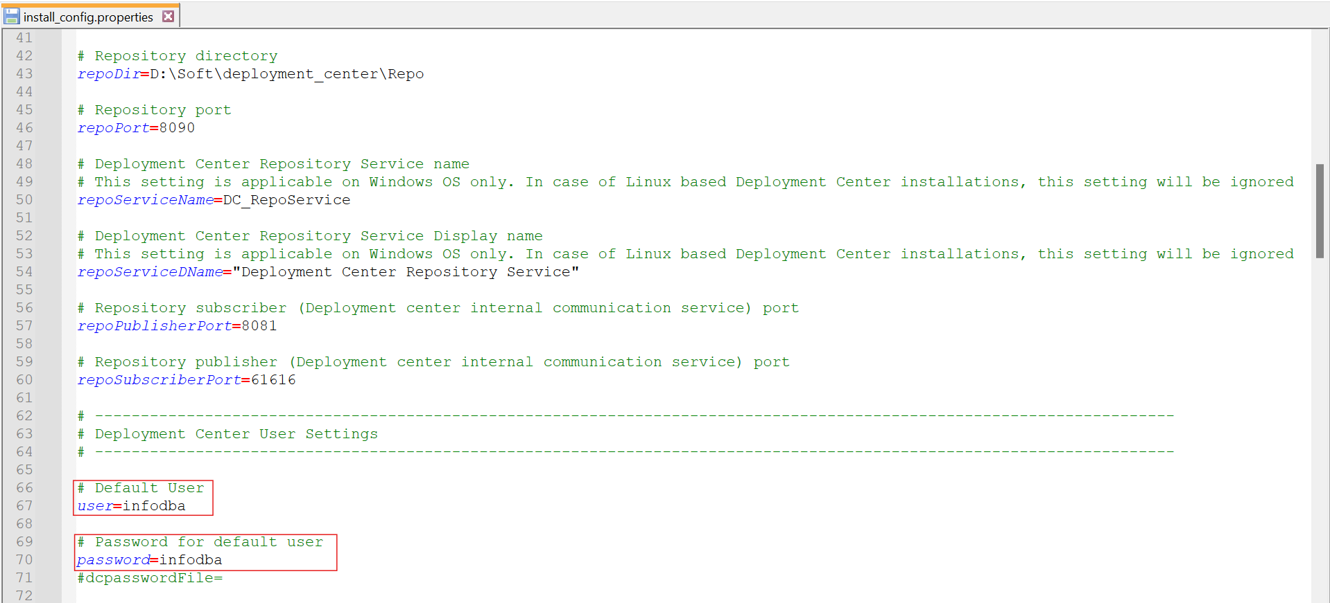
* **Step 5:** Copy the path of **deployment_center** folder and open that folder location in **Administrator CMD**.  
  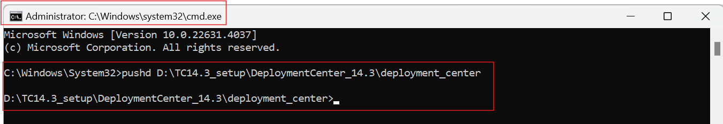
* **Step 6:** Run **“deployment_center.bat”** in CMD using the command given below.

**Command:** “deployment_center.bat -install –inputFile= install_config.properties”

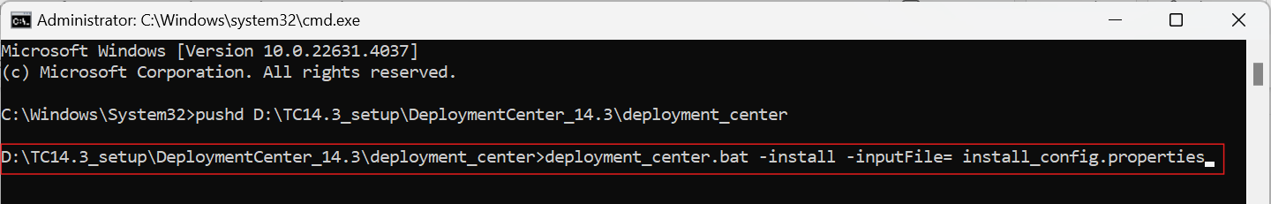

* **Step 7:** Deployment Center should be installed on your system. Copy the link highlighted in the snapshot below and open it in your browser.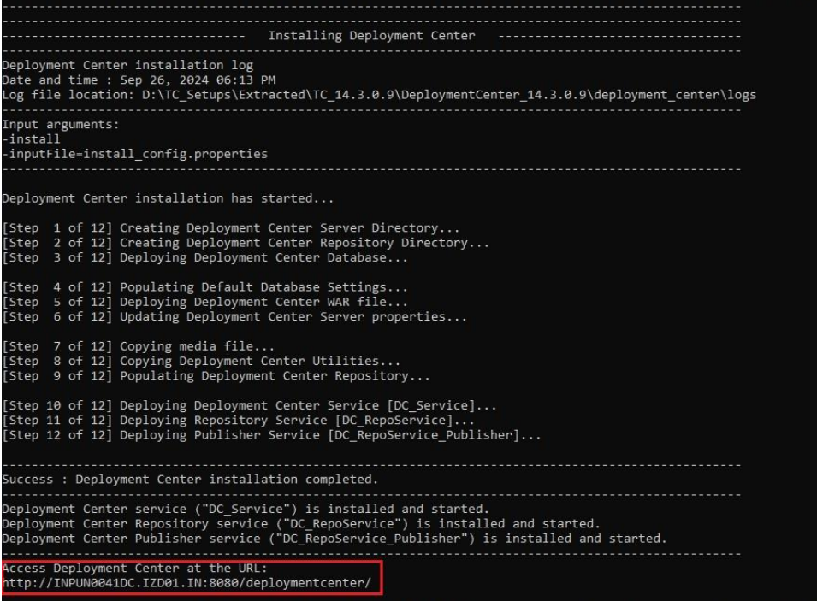
* **Step 8:** After successful installation of DC these 3 Services must be created.  
  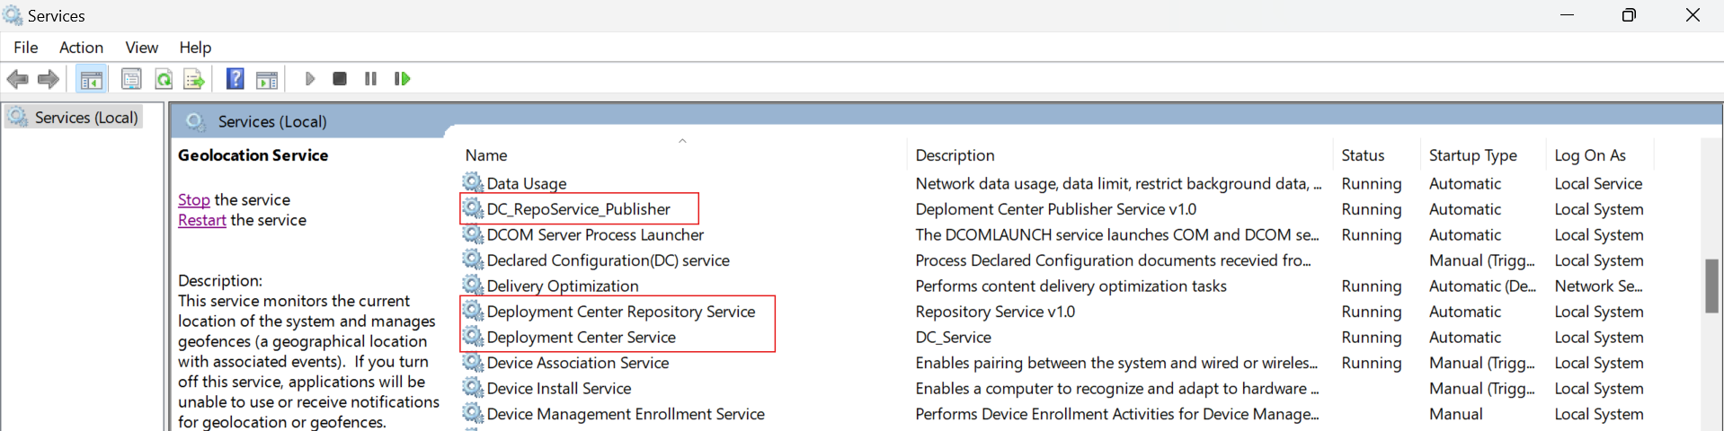

**TC Installation:**

* **Step 1:** First, copy the setups of “**Tc14.0.0.0_wntx64**”, “**Tc14.3.0.0_wntx64**”, “**Tc14.0.0.0_ActiveWorkspace6.3.1_wntx64**” and “**TcMicroserviceFramework_6.3.1_wntx64**” to software folder of DC   
  “D:\Soft\deployment_center\Repo\software”.  
  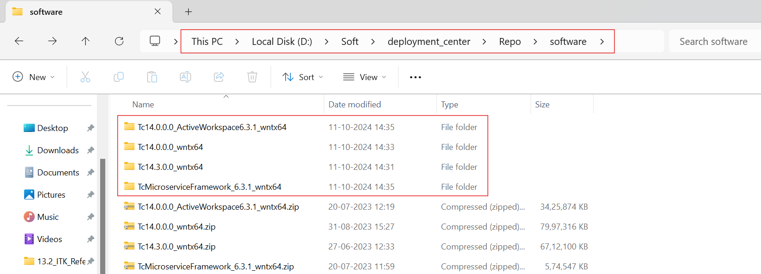
* **Step 2:** Open DC, click on Environments.  
  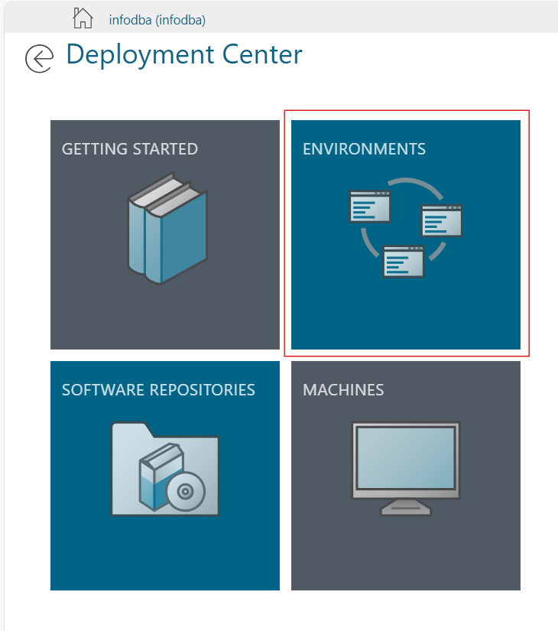
* **Step 3:** Click on (+) icon.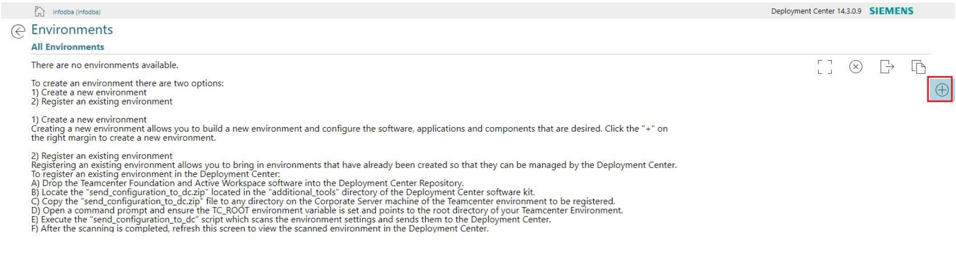
* **Step 4:** Select all four setups and click on Update Selected Software.  
  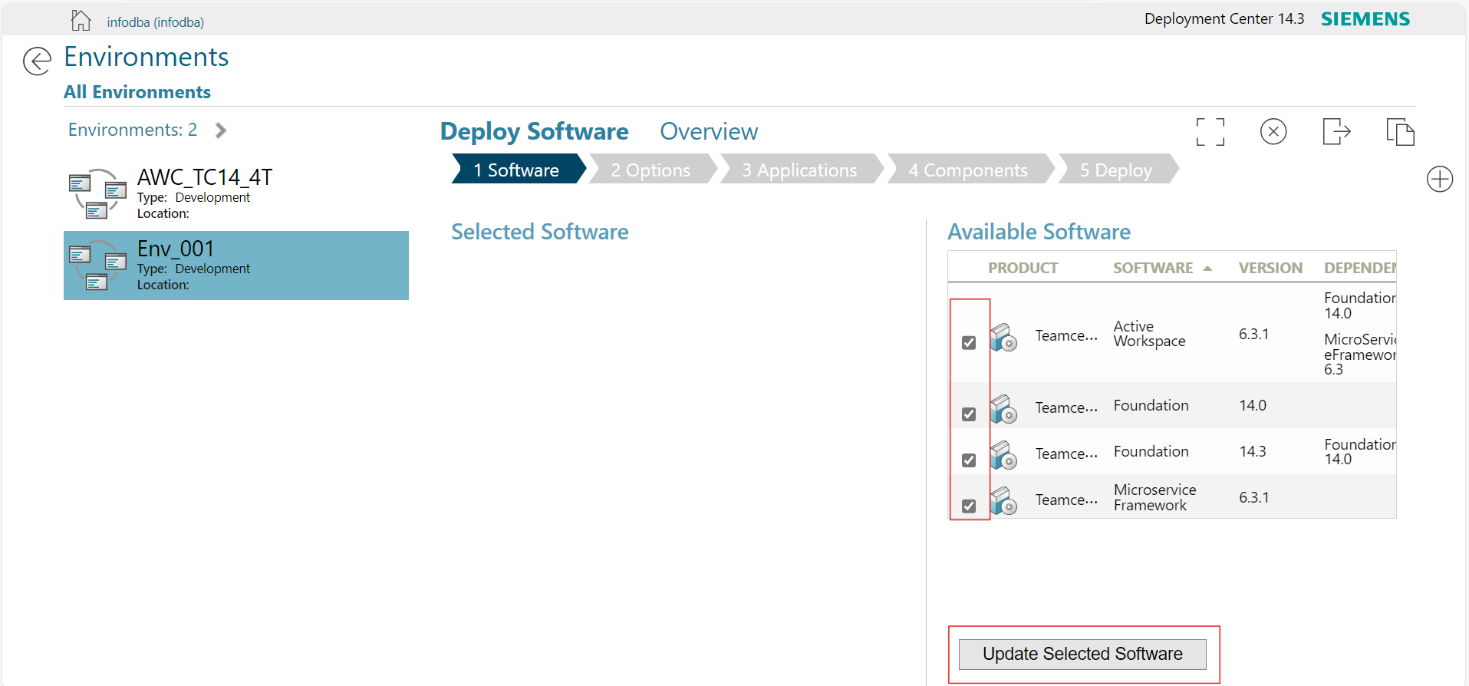
* **Step 5:** Click on “**Go to Options**”.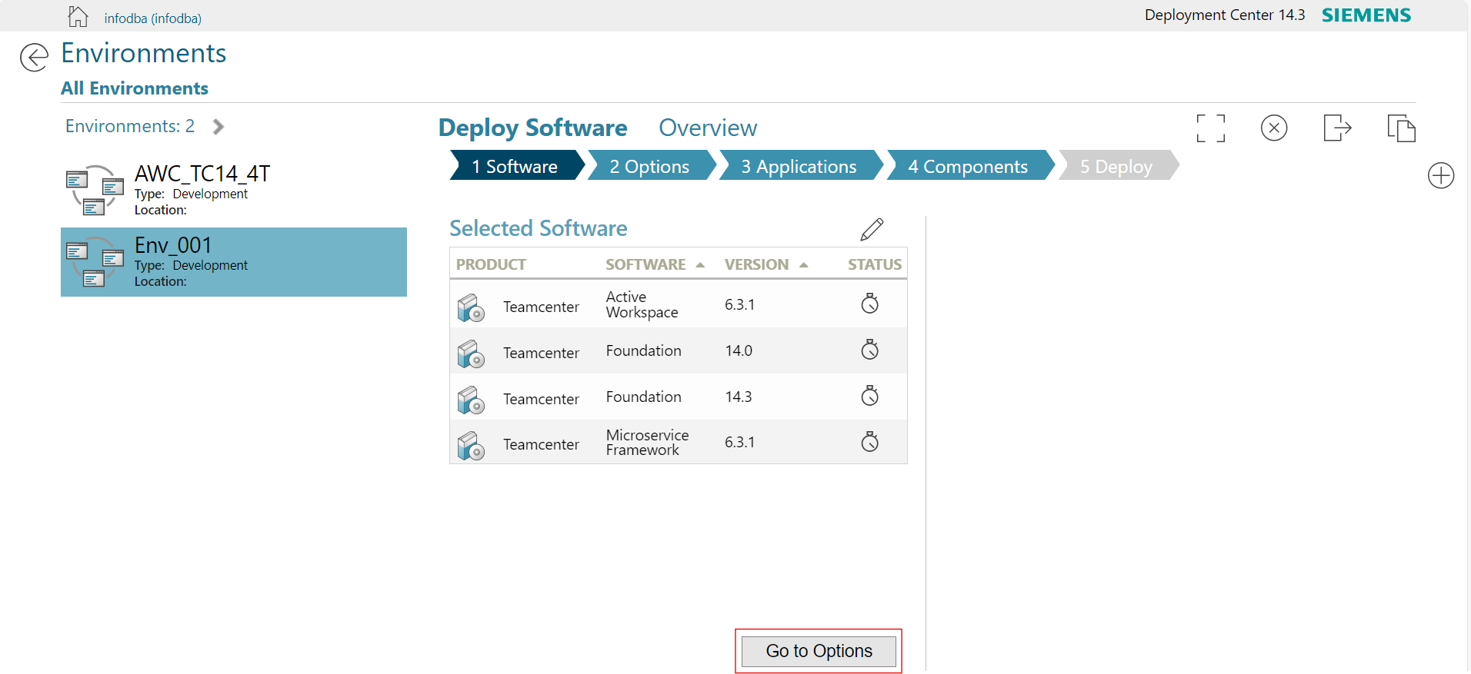
* **Step 6:** Click on “**Save Environment Options**”.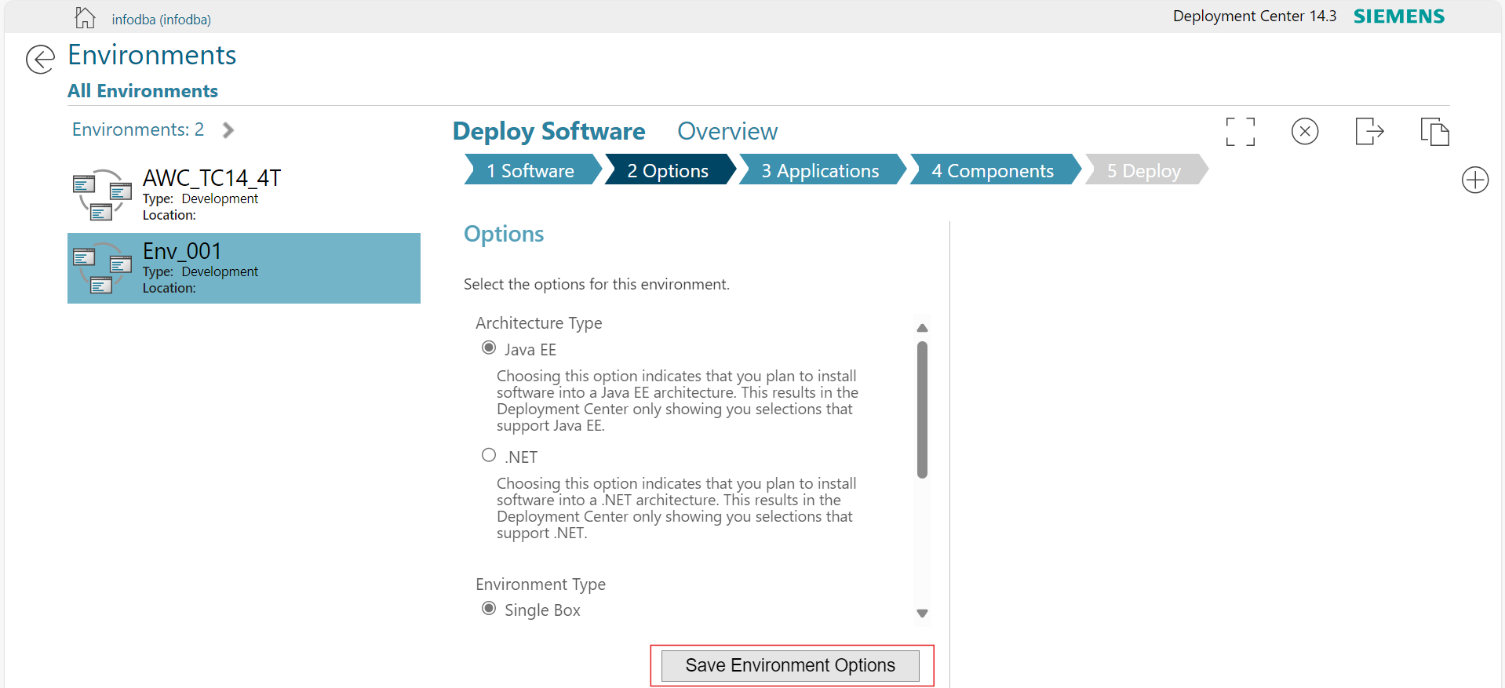
* **Step 7:** Click on “**Go to Components**”.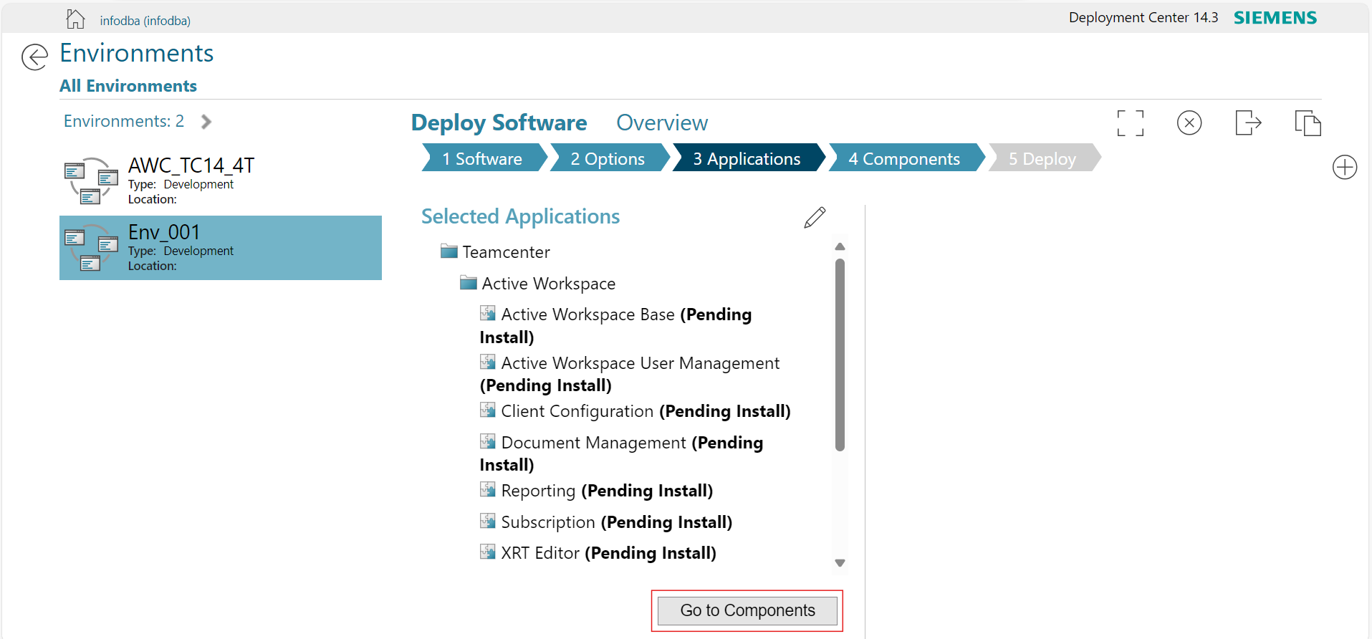
* **Step 8:** Click on (+) icon and select “**BMIDE 4-Tier**” and “**Rich** **client four-tier**”, then click on **Update Selected Components.**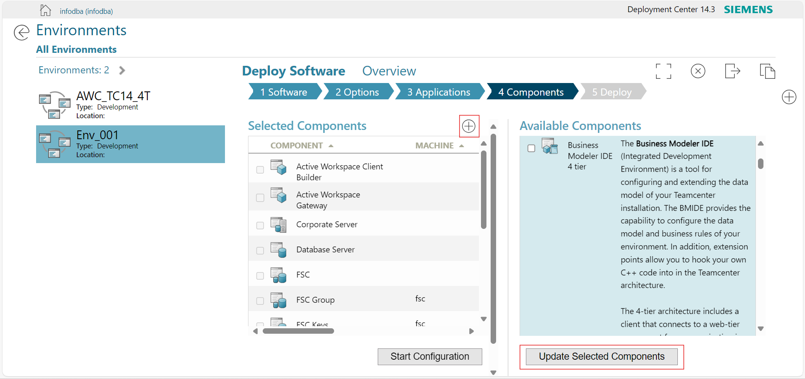

**Corporate Server**

* **Step 9:** Select **Corporate Server** and on the right sideClick on the **eye** button to view more options**.**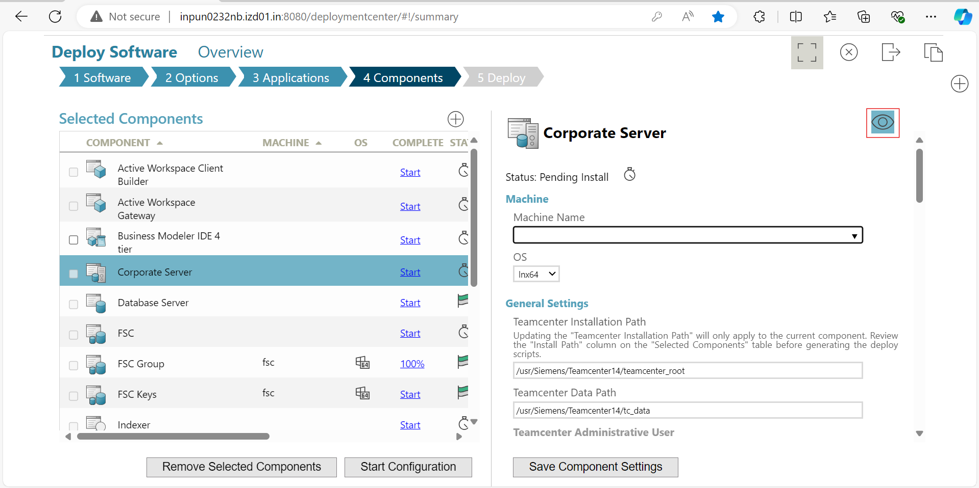
* **Step 10:** Fill the values as given below to all required text fields for successful installation.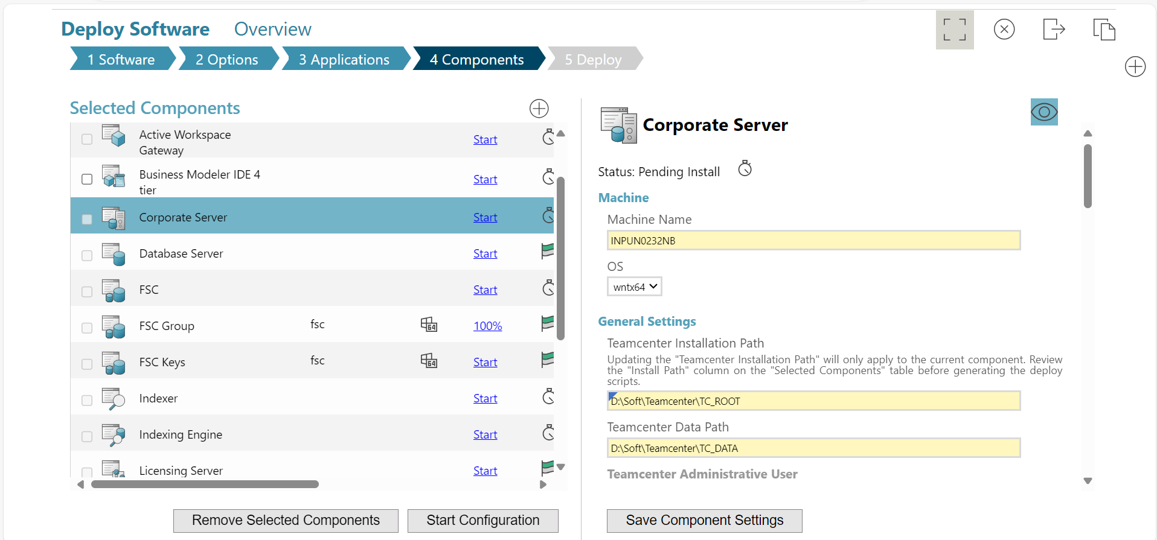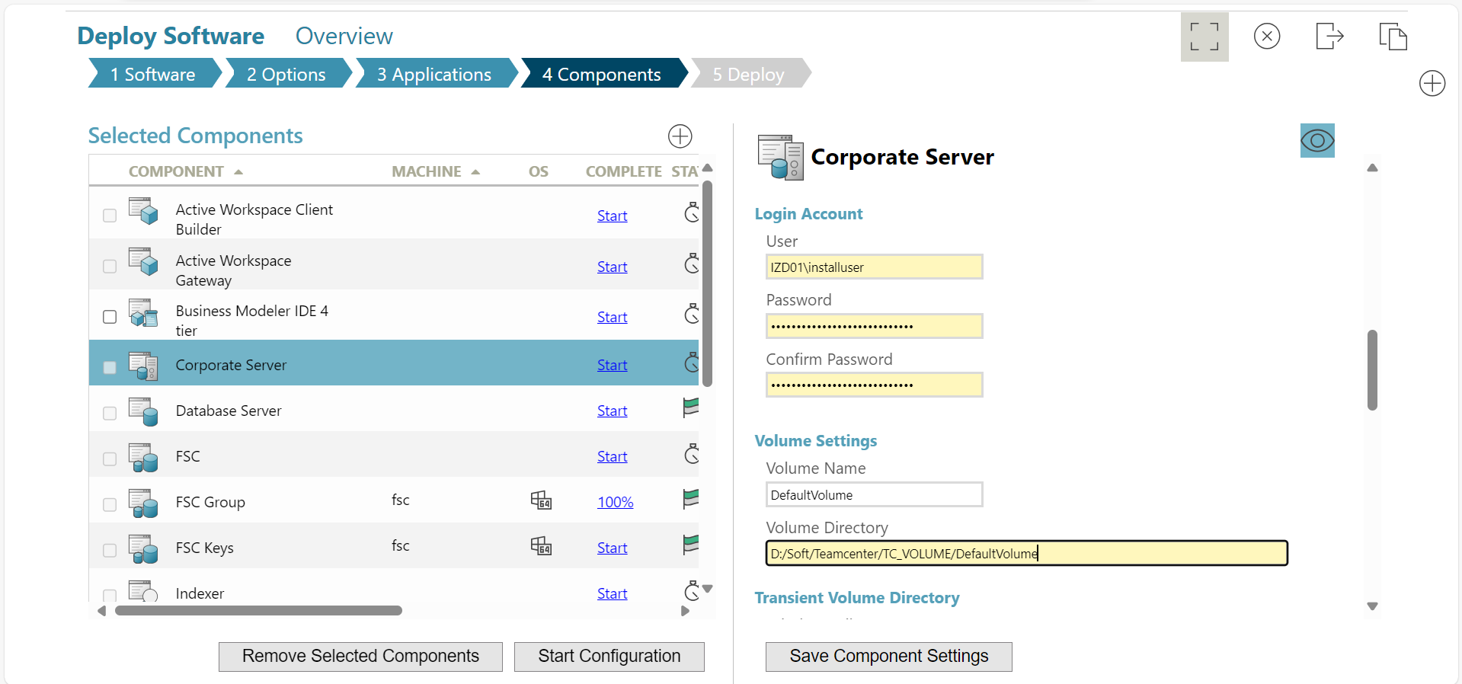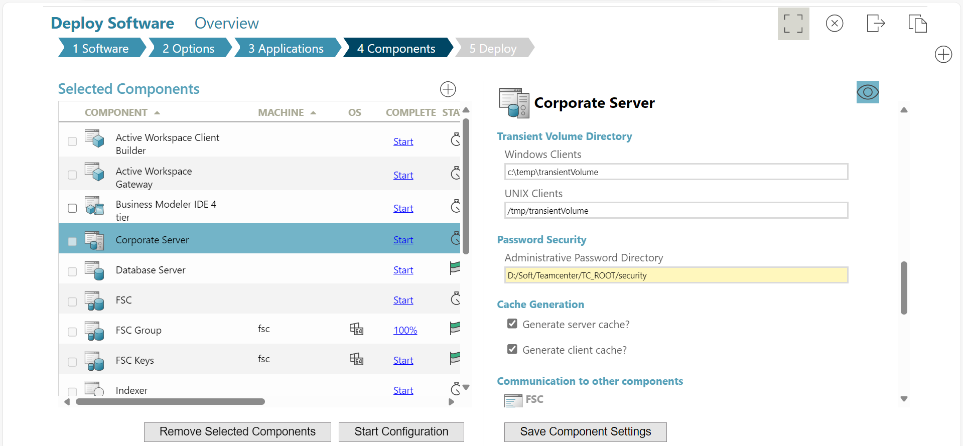

**Database Server**

* **Step 11:** Select **Database Server** and on the right sideClick on the **eye** button to view more options.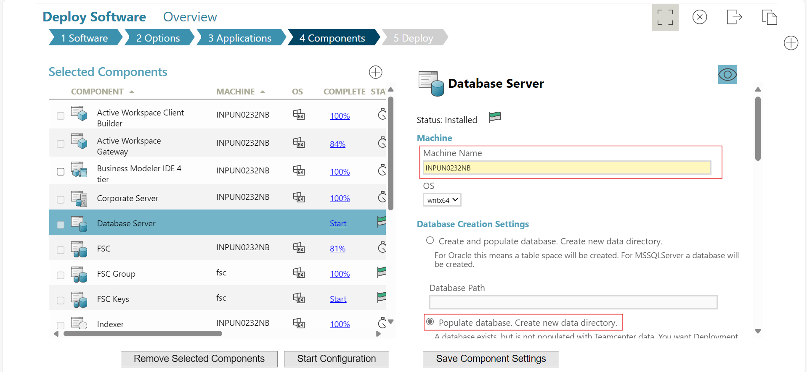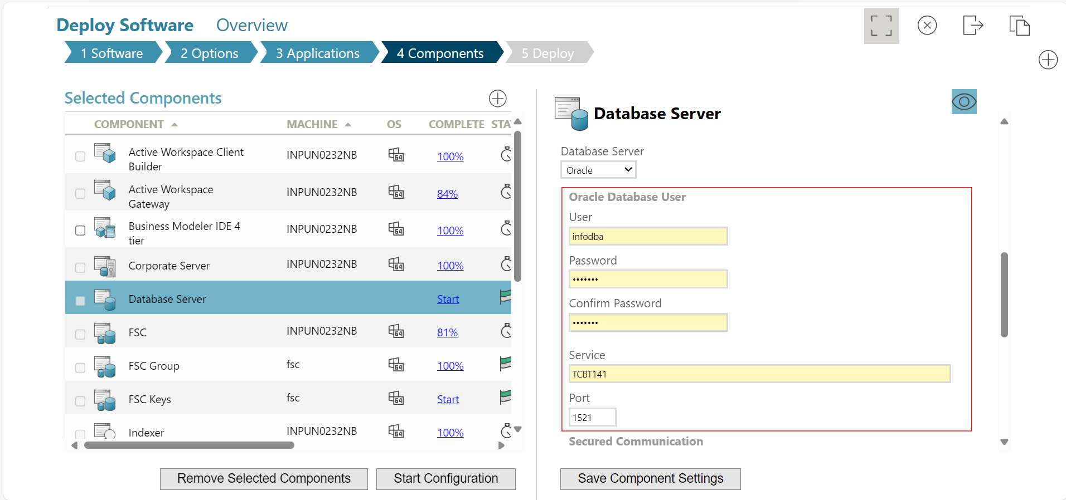
* **Step 12:** Click on **Save Component Settings.** 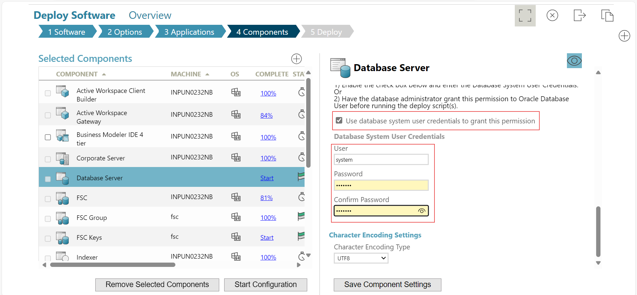

**FSC**

* **Step 13:** Select **FSC** and on the right sideClick on the **eye** button to view more options**.**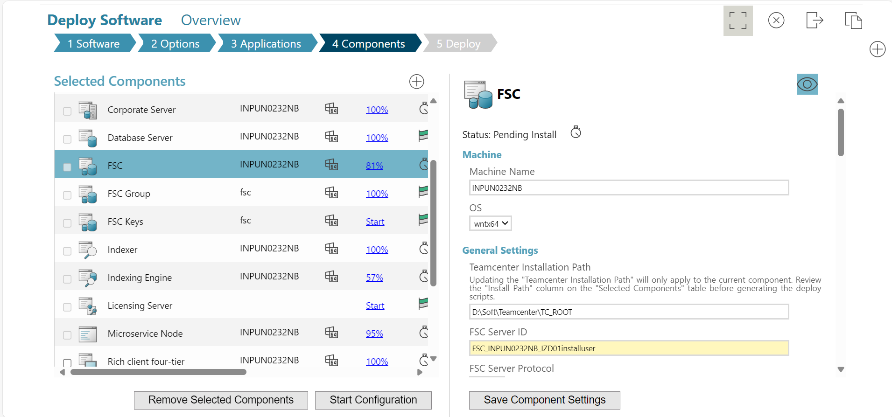
* **Step 14:** Click on **Save Component Settings.**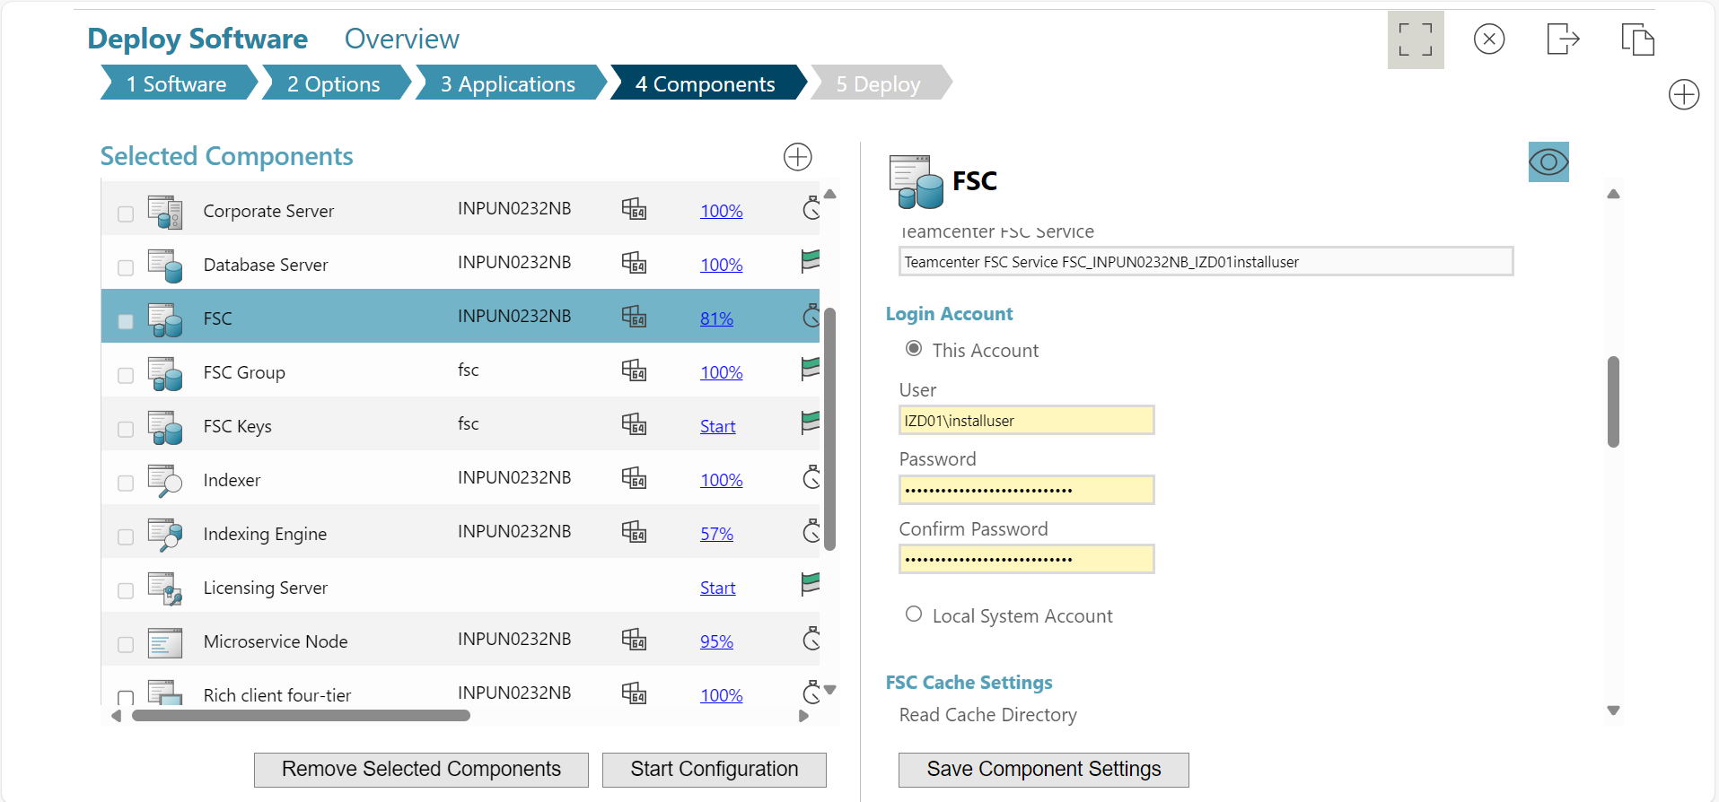

**FSC Keys**

* **Step 15:** Select **FSC Keys** and use **infodba** as key store password and then Click on **Save Component Settings**.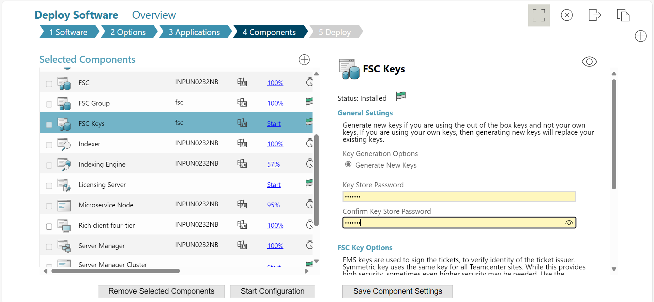

**Indexing Engine**

* **Step 15:** Select **Indexing Engine** and on the right sideClick on the **eye** button to view more options**.**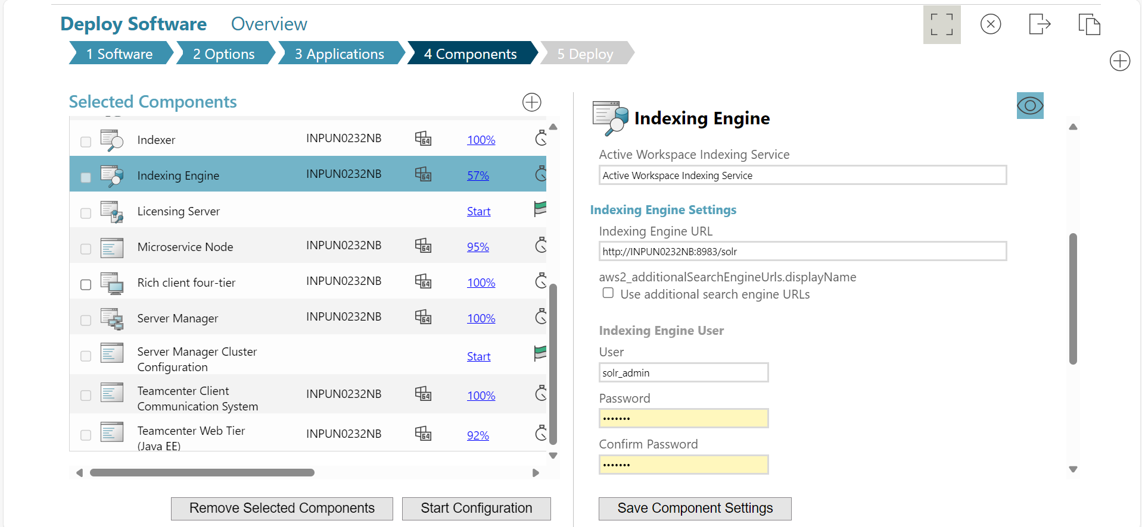
* **Step 16:** Click on **Save Component Settings.**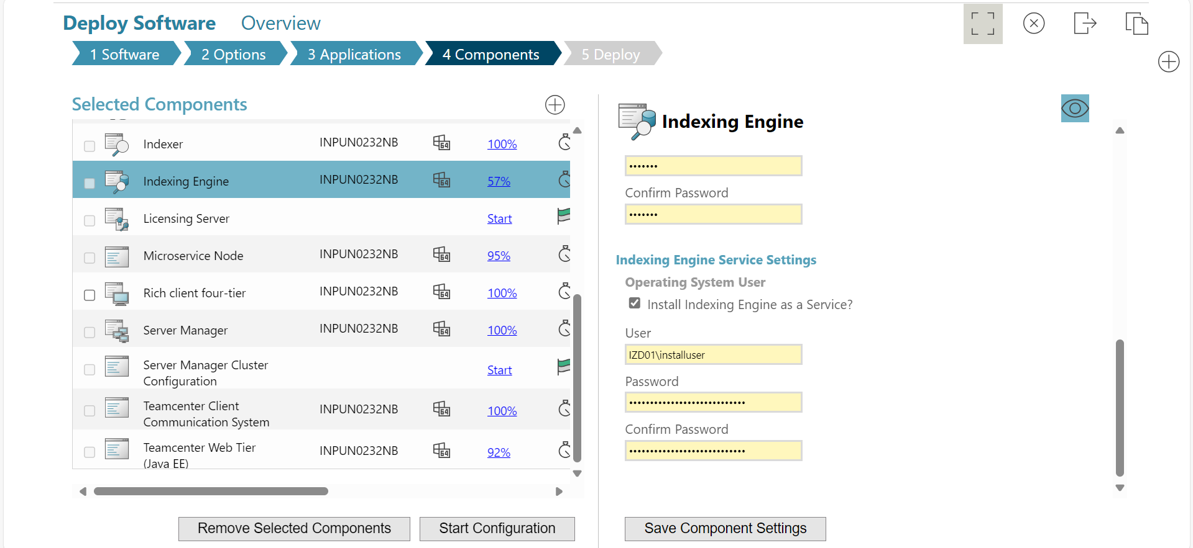

**Licensing Server**

* **Step 17:** Select **Licensing Server** and provide **10.0.0.13** as license machine name and then Click on **Save Component Settings**.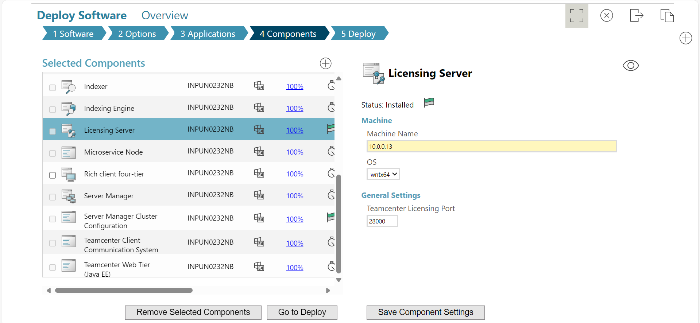

**Microservice Node**

* **Step 18:** Select **Microservice Node** and on the right sideClick on the **eye** button to view more options and set Keystore Password as “**infodba”** and then Click on **Save Component Settings.**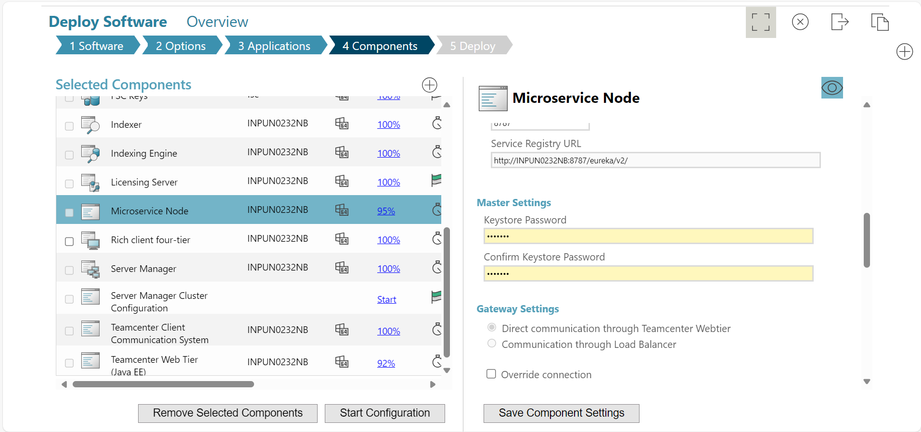

**Server Manager Cluster Configuration**

* **Step 19:** Select **Server Manager Cluster Configuration** and on the right sideClick on the **eye** button to view more.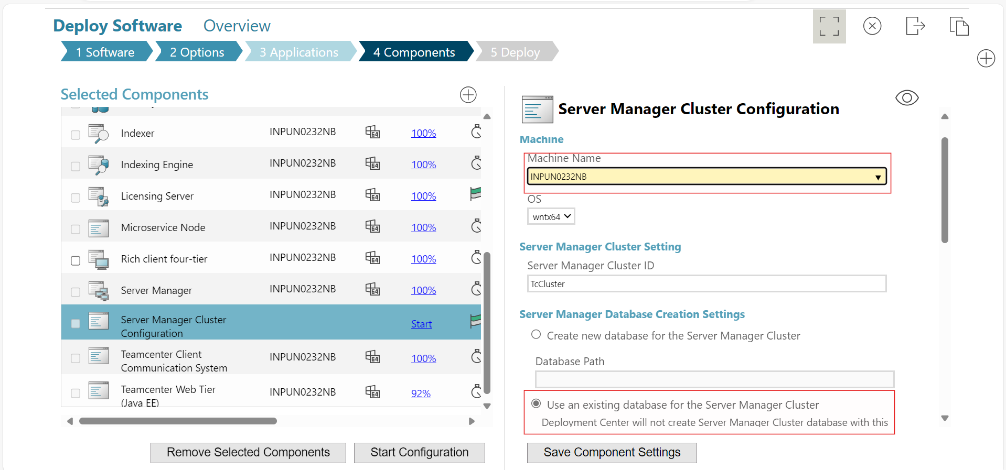
* **Step 20:** Set Database user as **system** and provide password as **infodba** and then Click on **Save Component Settings.** 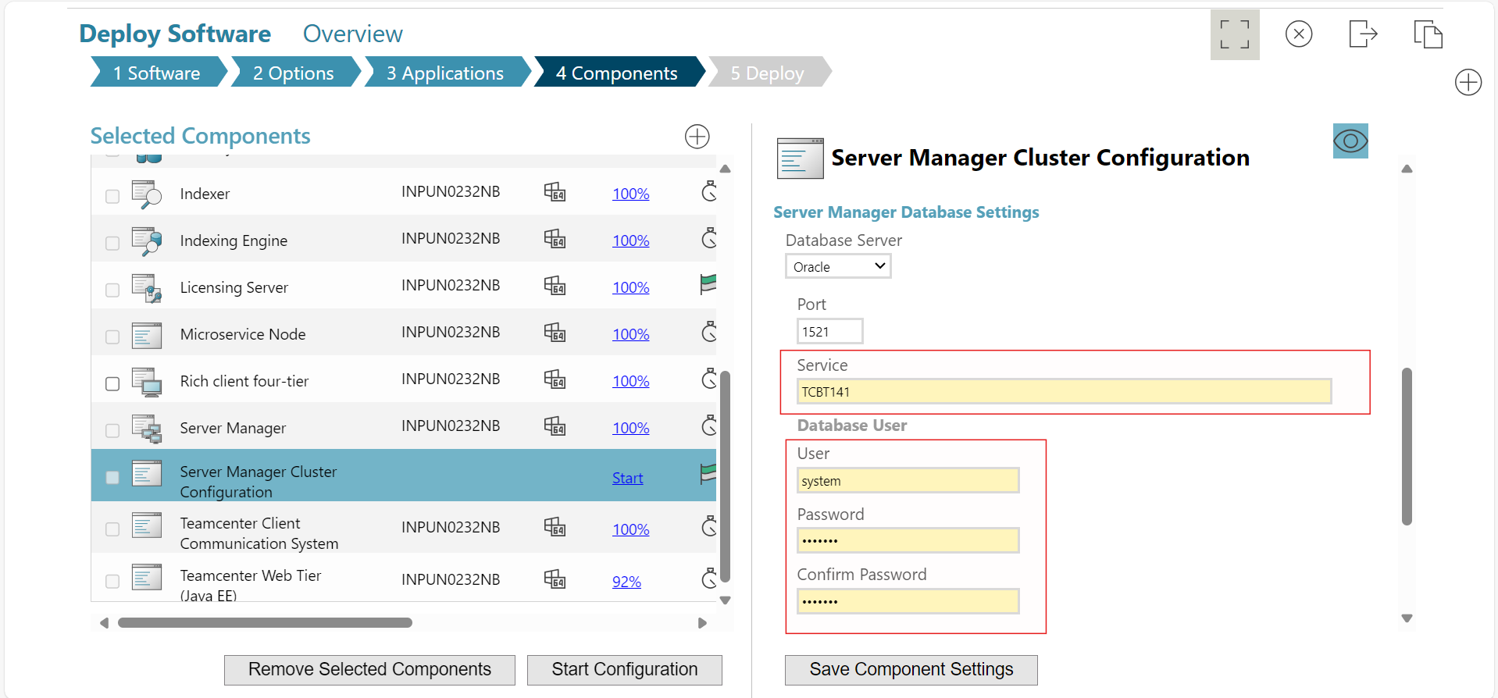

**Teamcenter Web Tier (Java EE)**

* **Step 21:** Set **4-Tier communication Port** as **8091.**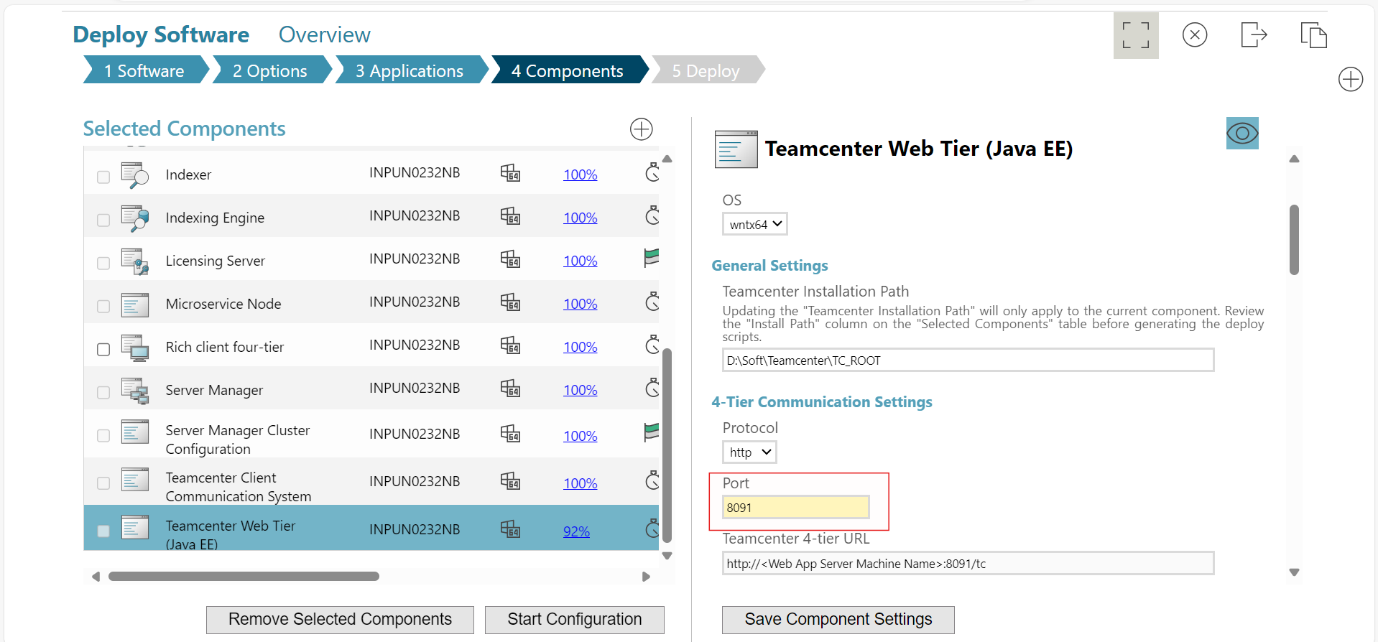
* **Step 21:** Enter your Machine name and then Click on **Save Component Settings.**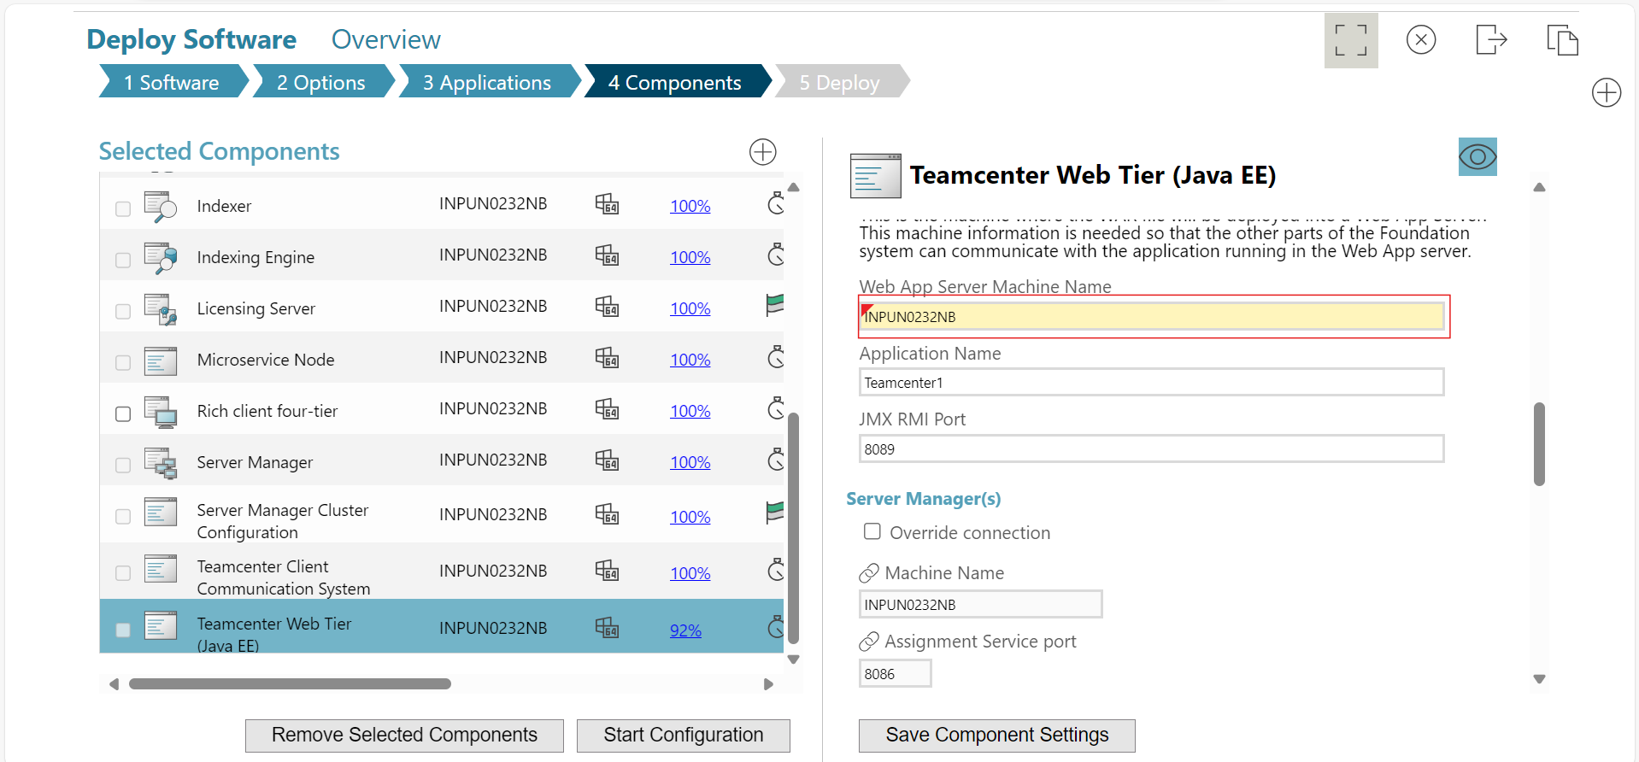

**Active Workspace Gateway**

* **Step 22:** In Gateway Setting select **http** & **Use Assigned FSC URLs** and then Click on **Save Component Settings.**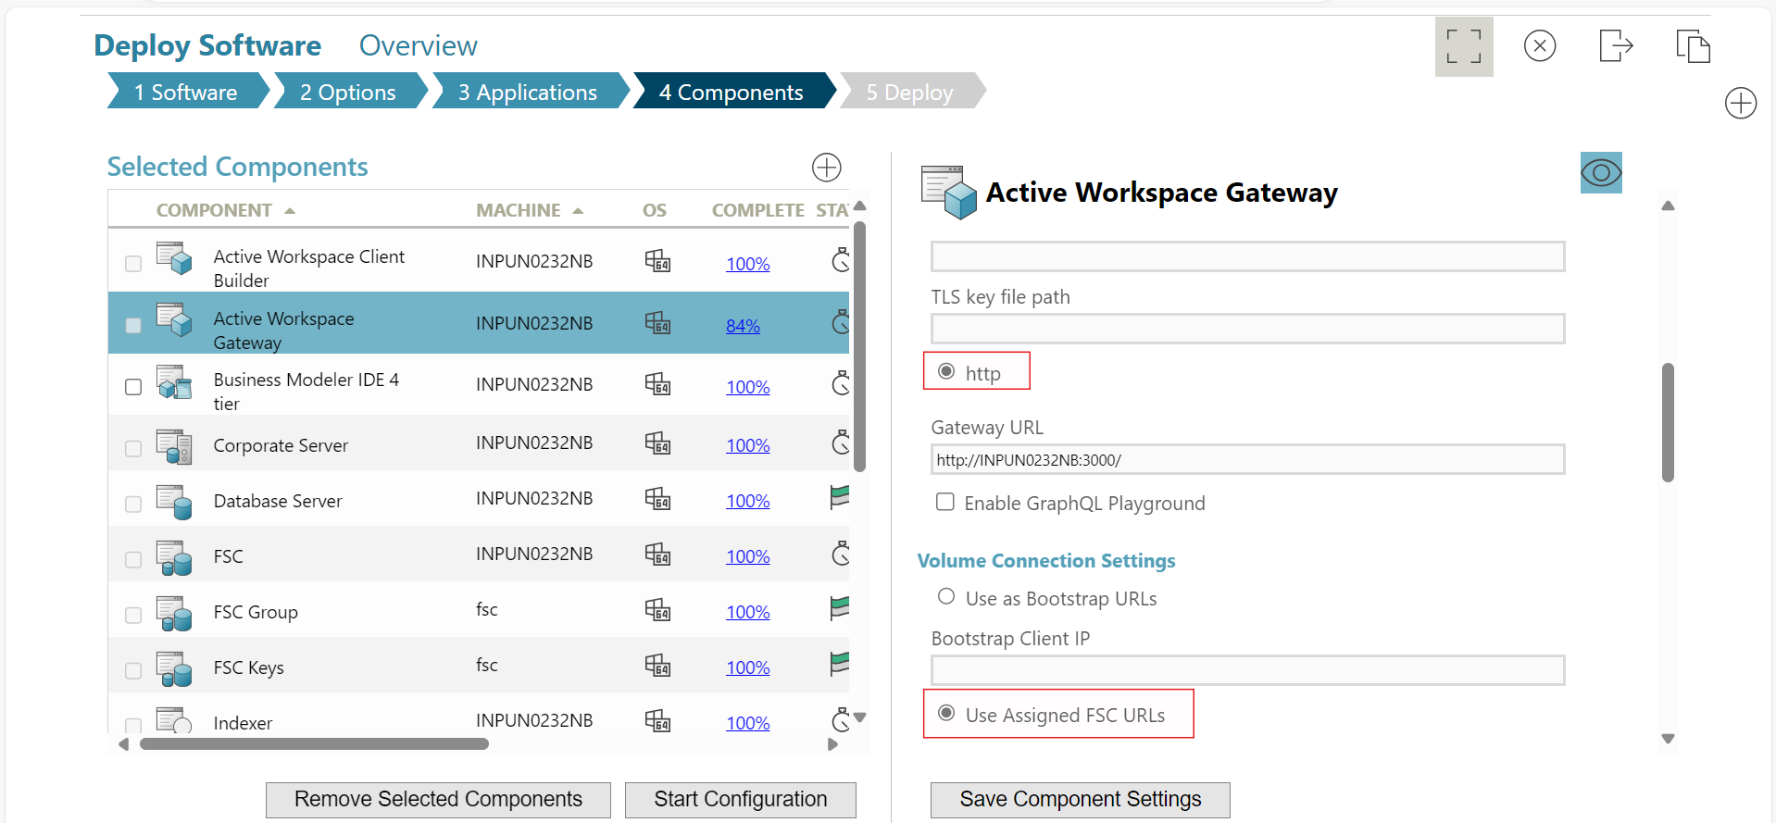

**Server Manager**

* **Step 22:** Select Startup Mode as **Service/Daemon** and then Click on **Save Component Settings**.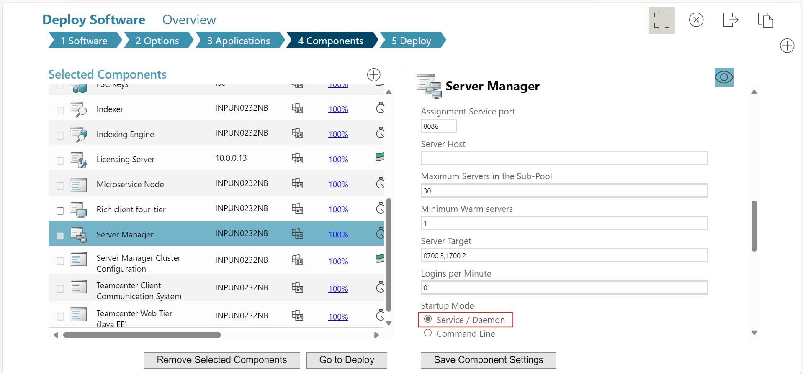
* **Step 23:** You can change log location for **Server Manager** and then after all changes click on **Go to Deploy.** 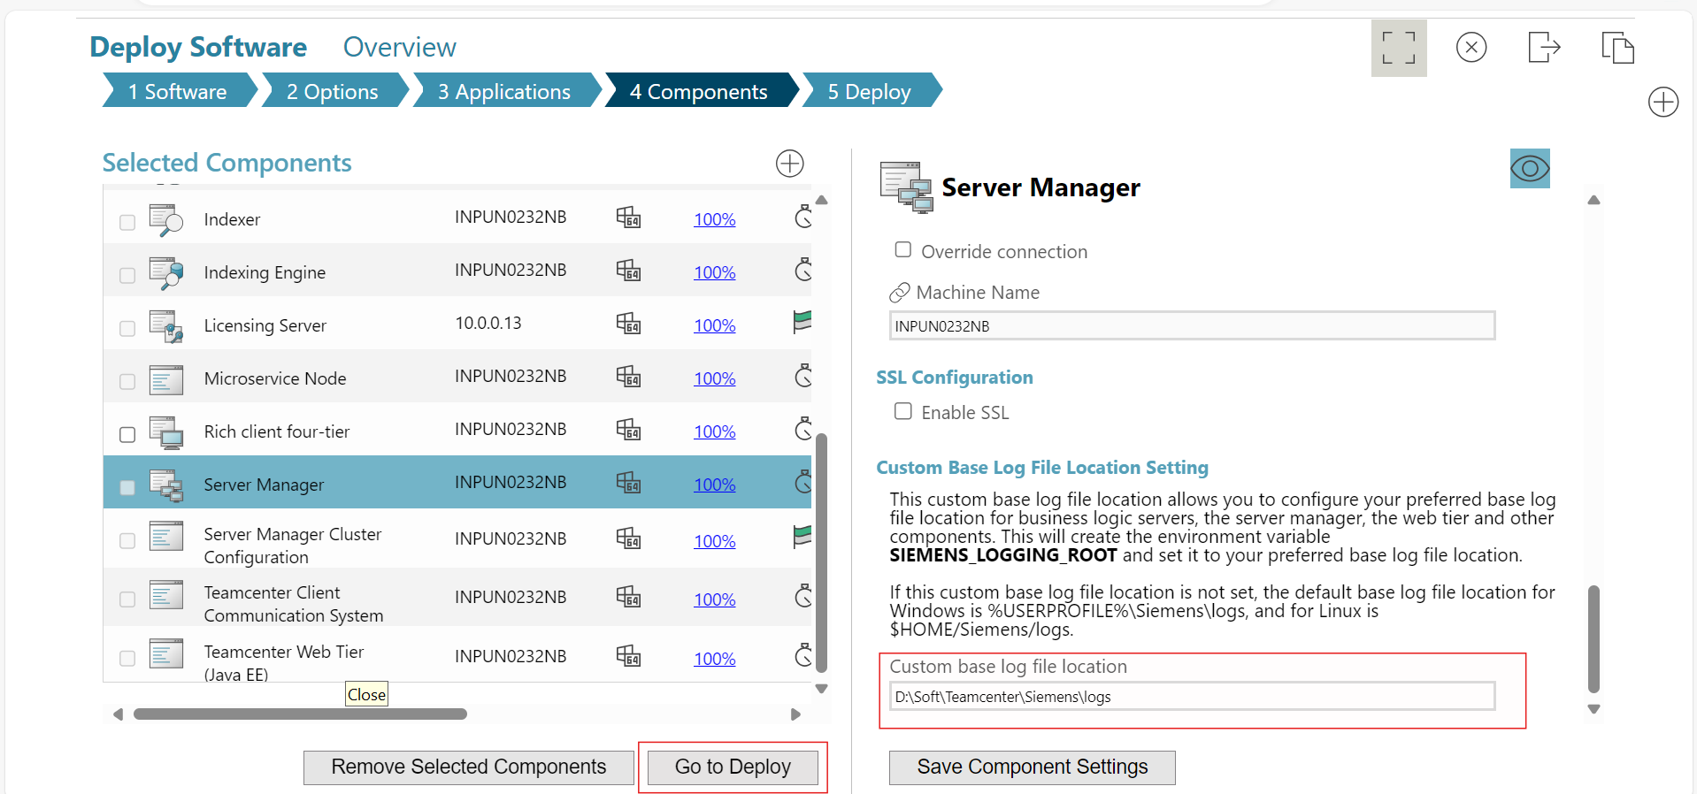
* **Step 24:** Now click on **Generate Install Scripts**.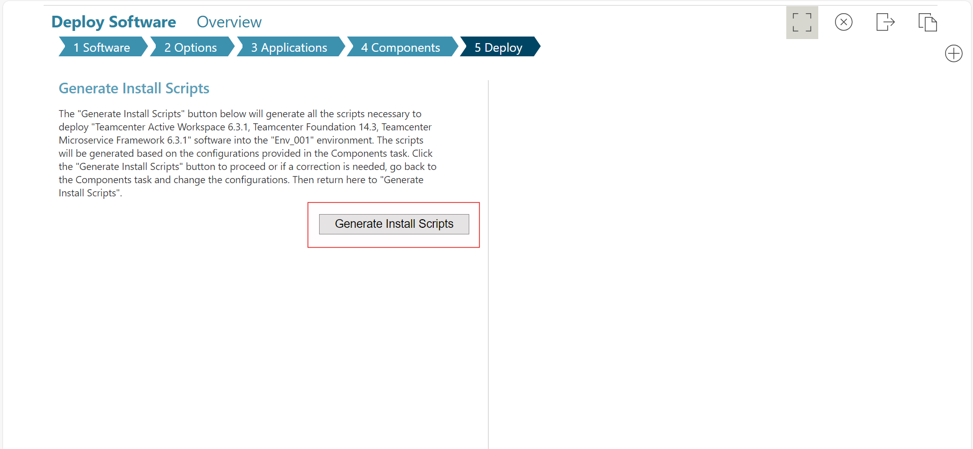
* **Step 25:** After that, on the right side, a deployment zip file will be generated at the highlighted location.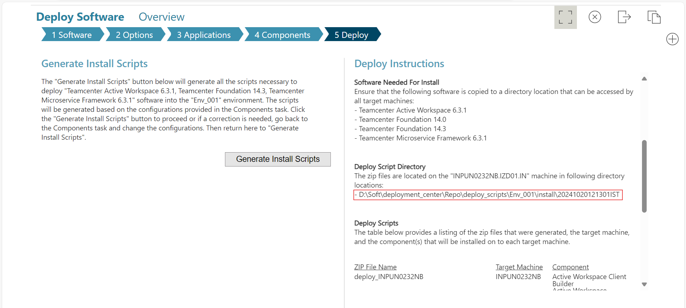
* **Step 26:** Copy that location, open it in your file explorer, and unzip the file.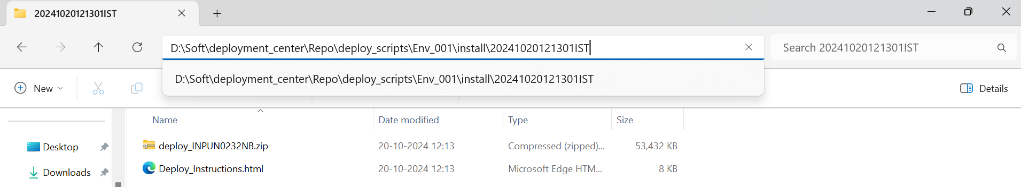
* **Step 27:** Copy unzipped folder location, open it in through **Admin CMD** and to start the deployment of TC_14.3 run command :  
  deploy.bat -dcusername=infodba -dcpassword=infodba -softwareLocation=D:\Soft\deployment_center\Repo\software.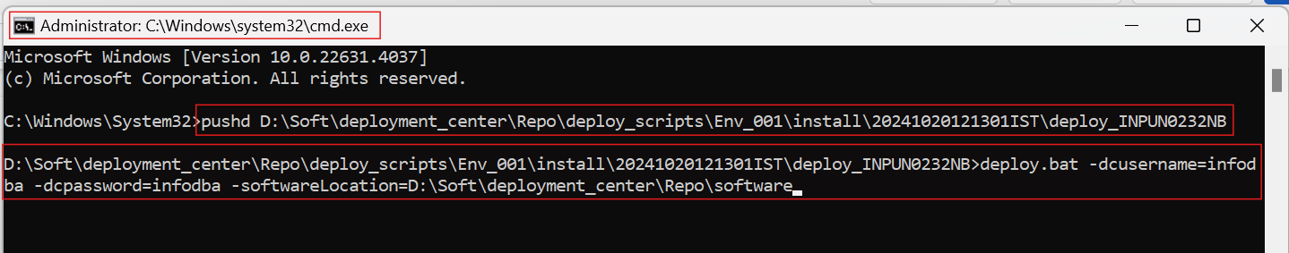

[**Note:** If any error throws you can go to Errors page at the last of this document.]

**Apache-tomcat-9.0.96 Installation:**

* **Step 1:** Run **apache-tomcat-9.0.96.exe** through Admin CMD. 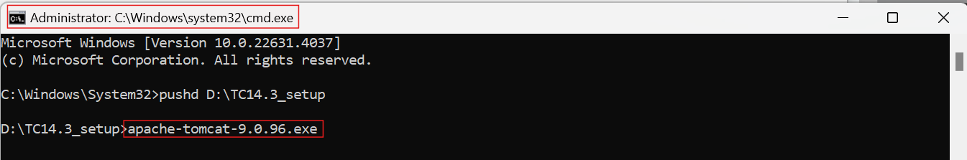
* **Step 2:** Click on **Next**.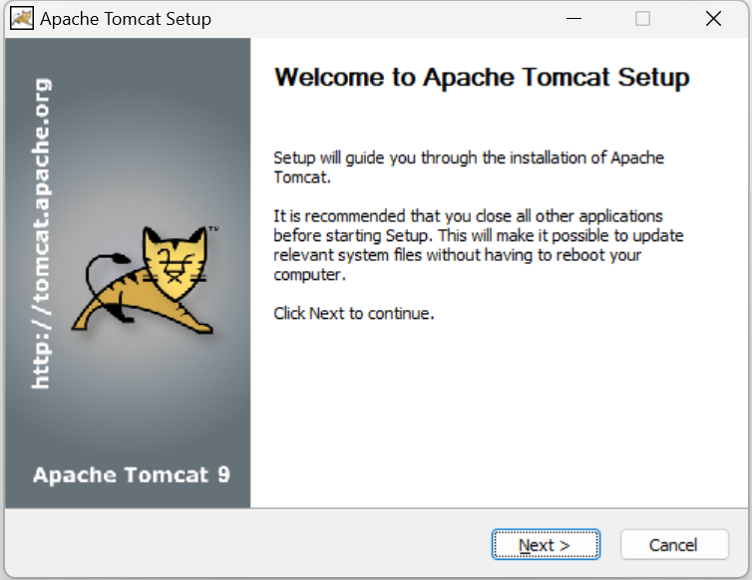
* **Step 3:** Click on **I Agree.**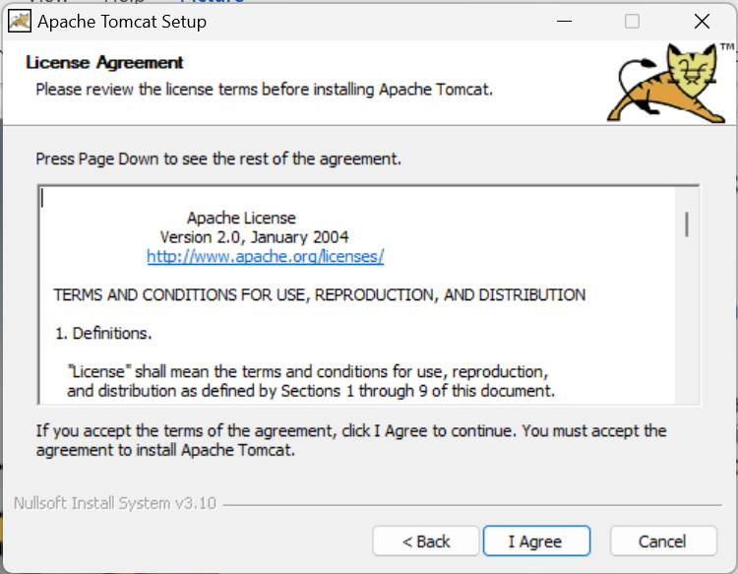
* **Step 4:** Click on **Next.**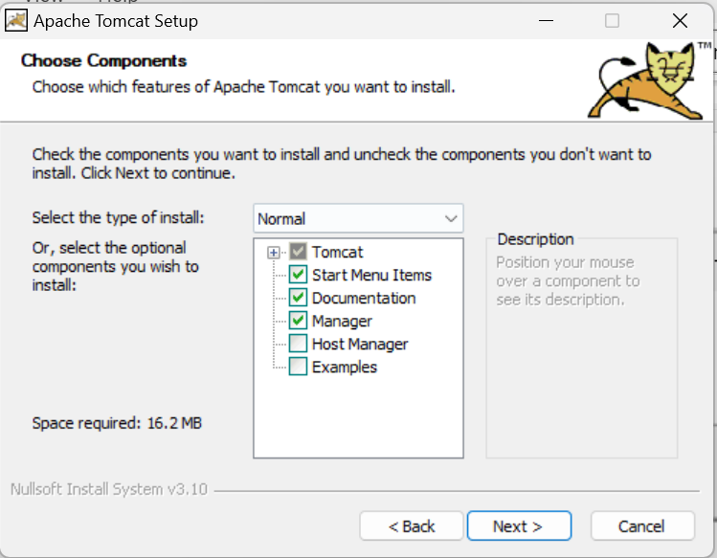
* **Step 5:** Change Connector Port to the same as **Teamcenter Web Tier (Java EE)** Port and Click on **Next.**  
  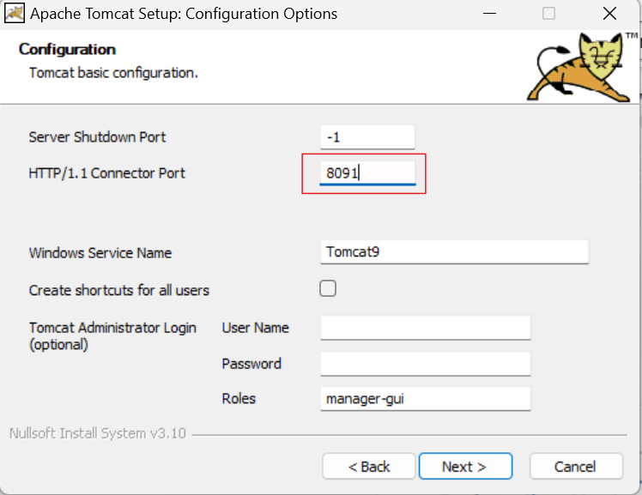
* **Step 6:** Click on **Next.**  
  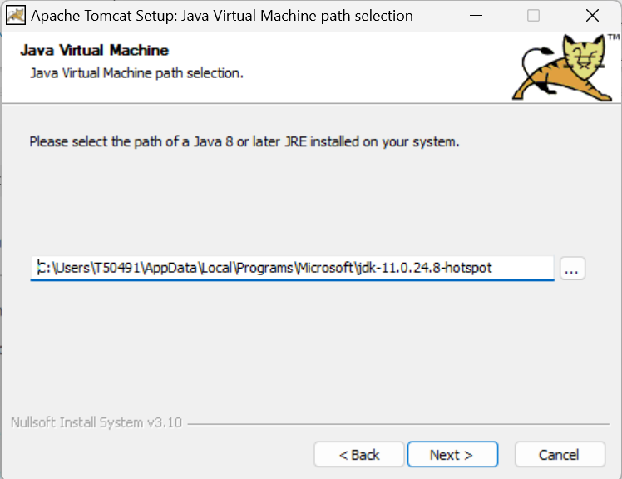
* **Step 7:** Click on **Install.**  
  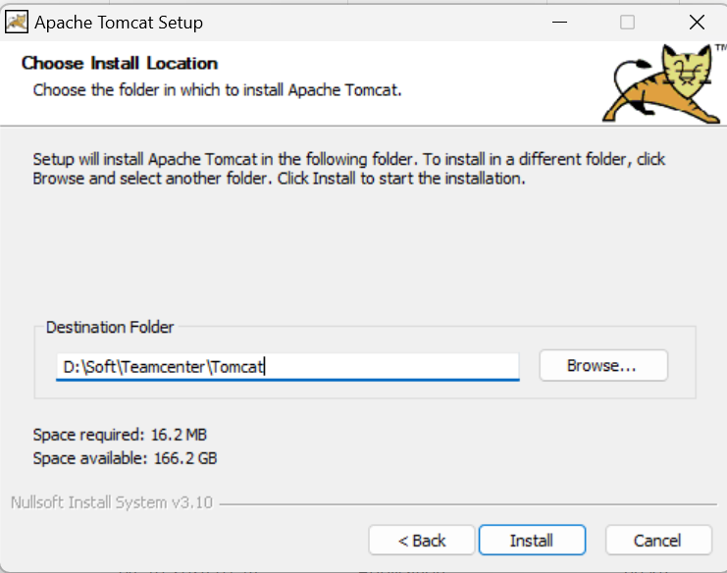
* **Step 8:** Now at location “D:\Soft\Teamcenter\TC_ROOT\web\Teamcenter1\deployment” you can find **tc.war** file generated after successful installation of Teamcenter through DC, Copy this war file.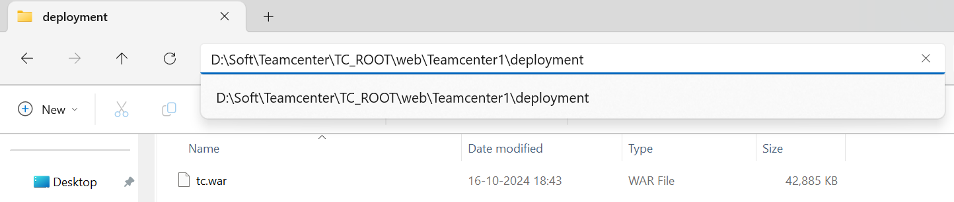
* **Step 9:** Paste copied tc.war file to “D:\Soft\Teamcenter\Tomcat\webapps” location. 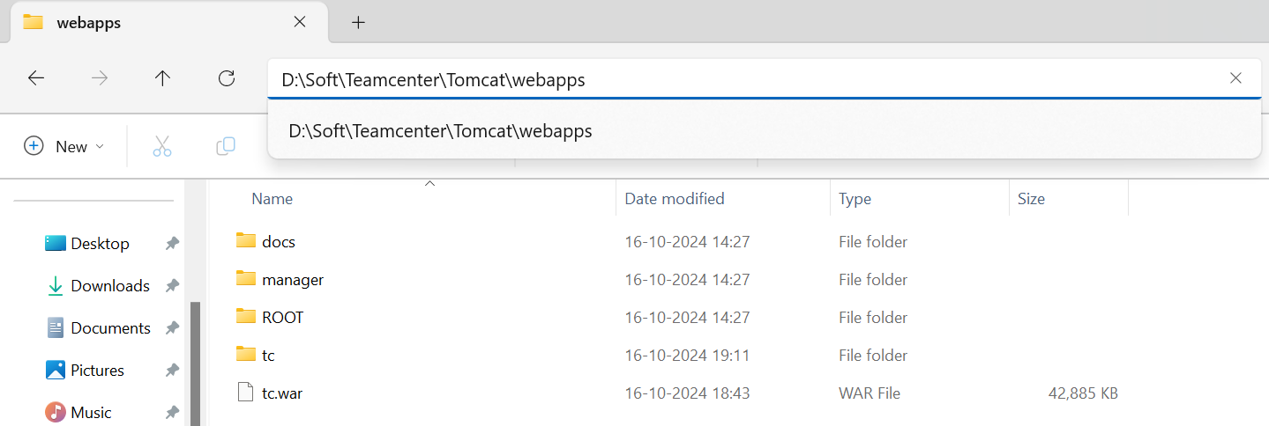
* **Step 10:** After installation of apache-tomcat in **Services** you can find one new service must have created with name “**Tomcat9**”.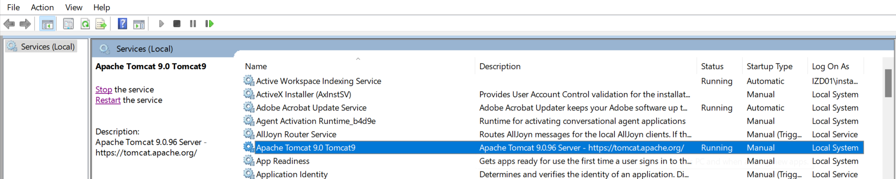
* **Step 11:** Right click on **Tomcat9** and go to properties. 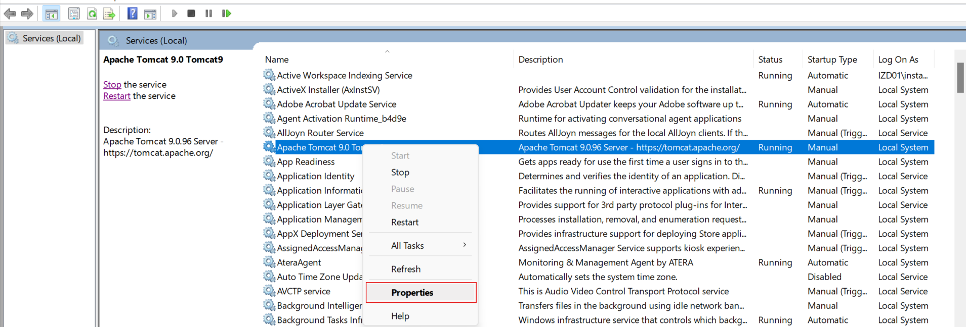
* **Step 12:** Make sure you select **Local System account** for option “Log on as” for starting services from **Services panel**.  
  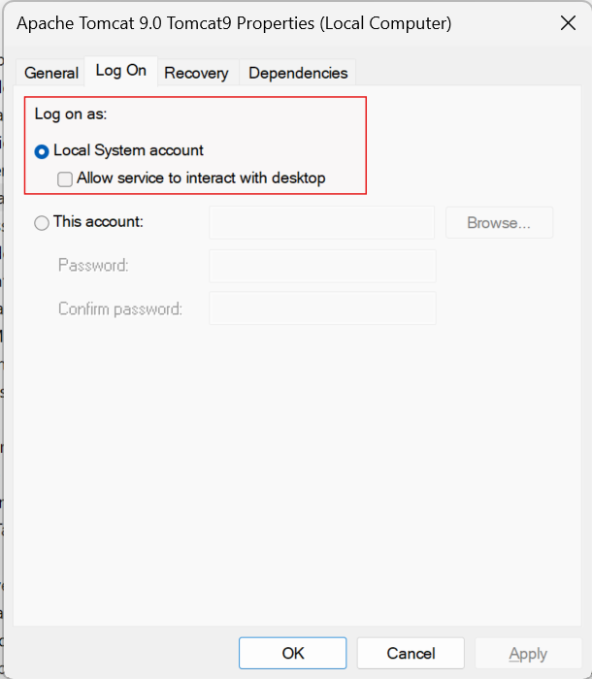

**ERRORS:**

* While running the deployment script, if you find any error, then go to the highlighted syslog location and open it. 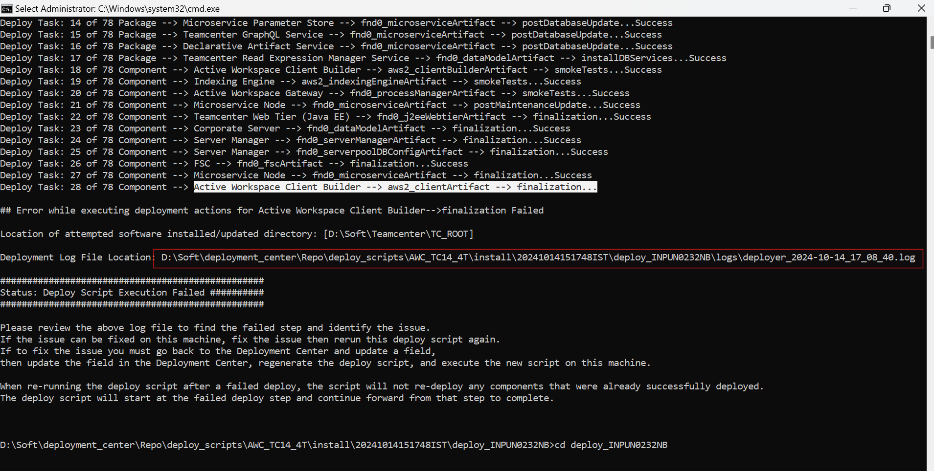
* If you move to the End of the file, you can find the error why your deployment failed, here **Due to no gateway available**, deployment failed.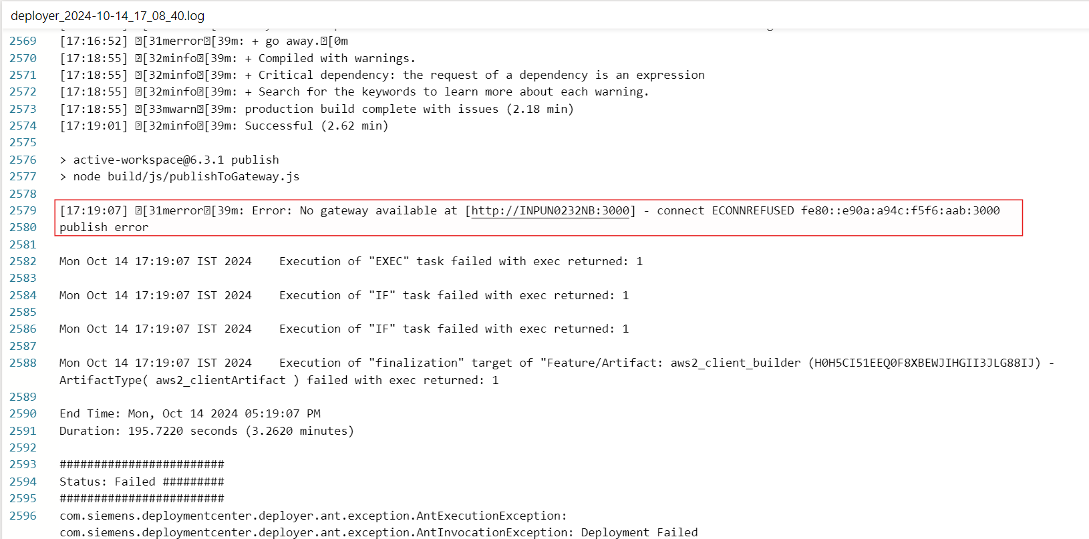

**Solution**

* Go to **Active Workspace Client Builder** and Uncheck **Publish Active Workspace Client assets** and then Click on **Go to Deploy**.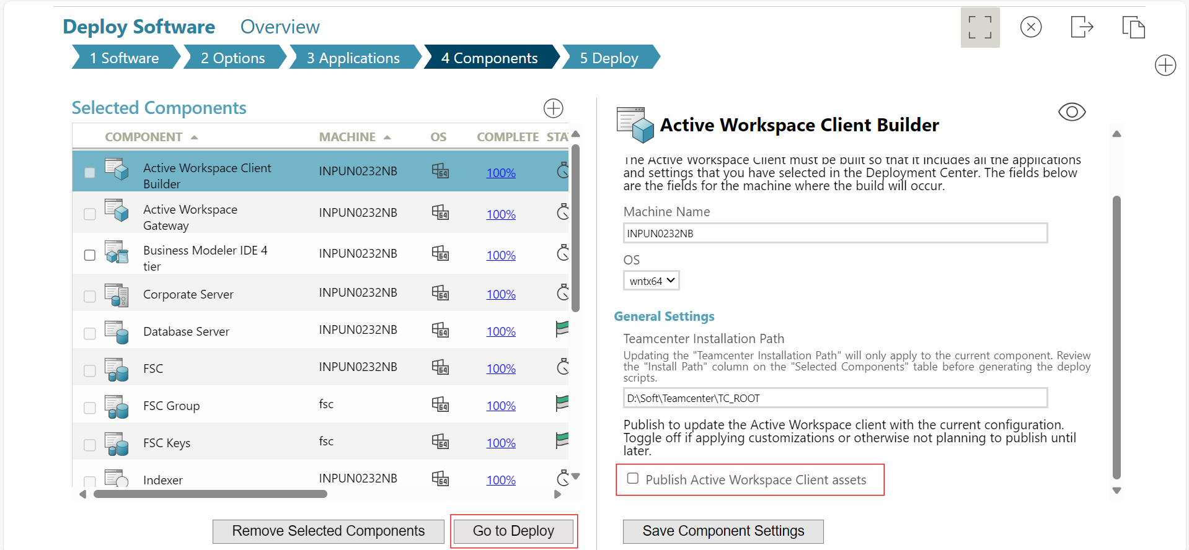
* Click on **Generate Install Scripts** and redeploy the TC14 deployment command from the new script generated by the above modification. 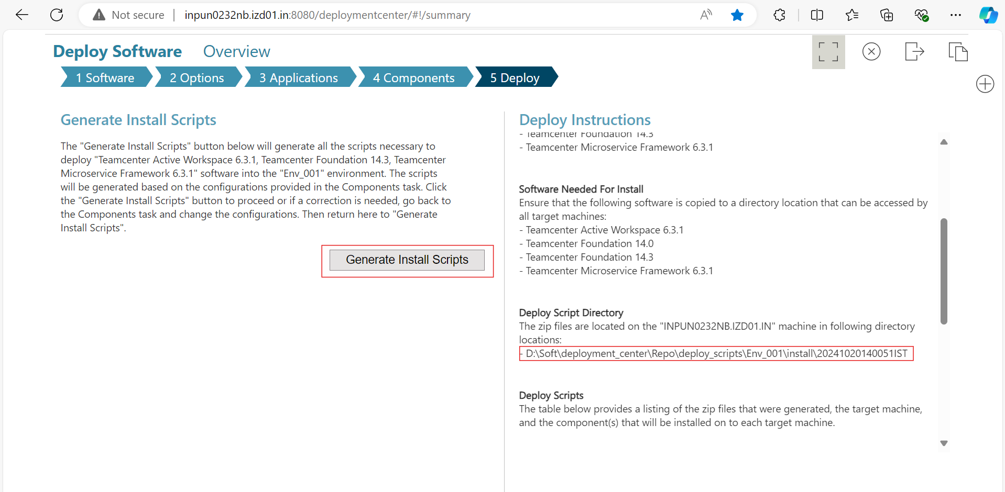
* Let the deployment be completed.
* Now Open the registry editor from windows and create the new parameters.  
  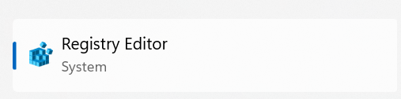
* Go to “Computer\HKEY_LOCAL_MACHINE\SYSTEM\CurrentControlSet\Services\Tcpip6\Parameters” then right click on parameter - > New -> DWORD (32 bit) Value  
  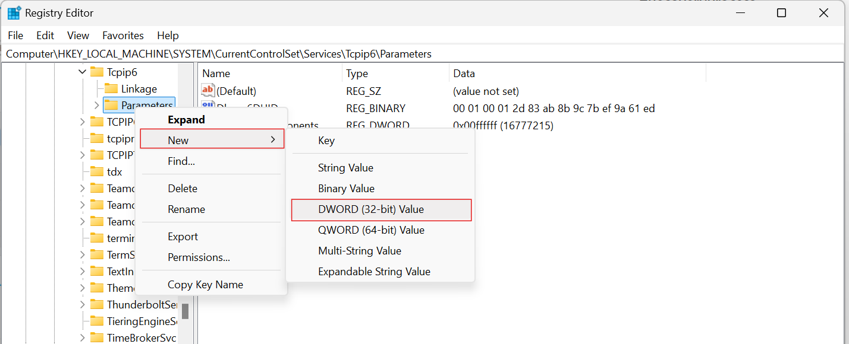
* Give Value name as **“DisabledComponents”** and Value data as “**ffffff**” and then click OK.  
  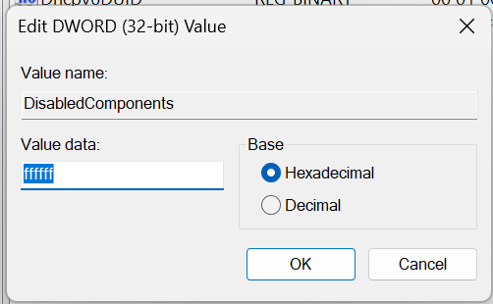
* Reboot the System, go to “D:\Soft\Teamcenter\TC_ROOT\aws2\stage” location using **CMD** and run **initenv.cmd** and then **awbuild.cmd.**  
  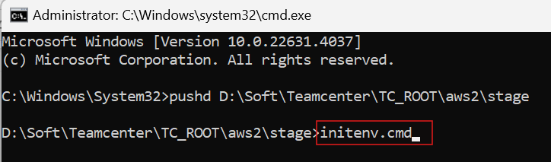
* It will publish the gateway and allow to login to AWC 6.3 using URL **http://localhost:3000.**